PROJECT REPORT



Submitted By :

Movin Kalta (15502)

Sarthak Awasthi (15505)

Anshul Dhiman (15517)

Akash Sood (15518)

**ROCKET TRAJECTORY SIMULATION**

ABSTRACT :

In this model we shall simulate the trajectory of a rocket given initial conditions and physical parameters. Numerical analysis is used to simulate the flight of the rocket, including effects due to thrust, change in mass and gravity**.**

When we think of rockets (or jet engines) we rarely think of balloons. Instead, we think of the big rockets that carry satellites, supplies, or people into space. However, balloons and rockets are very similar. The only significant difference is the way the pressurized gas is produced. With rockets, the gas is produced by burning propellants that can be solid or liquid in form or a combination of the two.

The drag coefficient, Equation 1, is used as input to the dynamics model. The drag force of the rocket is calculated using Equation 2.

*cd*=*Fd /* 0.5\**ρ* v*2 \**A* (1)

*Fd*=0.5\**ρ*v*2 *\* cd*A* (2)

Introduction

**Rocket propulsion** is any method used to accelerate rocket and artificial satellites. There are many different methods. Each method has drawbacks and advantages, and rocket propulsion is an active area of research. However, most rockets today are propelled by forcing a gas from the back/rear of the vehicle at very high speed through a supersonic de Laval nozzle. This sort of engine is called a rocket engine.

All current rockets use chemical rockets (bipropellant or solid-fuel) for launch, though some (such as the Pegasus rocket and SpaceShipOne) have used air-breathing engines on their first stage. Most satellites have simple reliable chemical thrusters (often monopropellant rockets) or resistojet rockets for orbital station-keeping and some use momentum wheels for attitude control. Soviet bloc satellites have used electric propulsion for decades, and newer Western geo-orbiting spacecraft are starting to use them for north-south station keeping and orbit raising. Interplanetary vehicles mostly use chemical rockets as well, although a few have used ion thrusters and Hall effect thrusters (two different types of electric propulsion) to great success.

**Propulsion** means to push forward or drive an object forward . The term is derived from two Latin words: pro, meaning before or forward; and pellere, meaning to drive. A **propulsion system** consists of a source of mechanical power, and a propulsor (means of converting this power into propulsive force).

The process of imparting a force to a flying vehicle, such as a missile or a spacecraft, by the momentum of ejected matter. This matter, called propellant, is stored in the vehicle and ejected at high velocity. In chemical rockets the propellents are chemical compounds that undergo a chemical combustion reaction, releasing the energy for thermodynamically accelerating and ejecting the gaseous reaction products at high velocities. Chemical rocket propulsion is thus differentiated from other types of rocket propulsion, which use nuclear, solar, or electrical energy as their power source and which may use mechanisms other than the adiabatic expansion of a gas for achieving a high ejection velocity. Propulsion systems using liquid propellants (such as kerosine and liquid oxygen) have traditionally been called rocket engines, and those that use propellants in solid form have been called rocket motors.

Performance

The performance of a missile or space vehicle propelled by a rocket propulsion system is usually expressed in terms of such parameters as range, maximum velocity increase of flight, payload, maximum altitude, or time to reach a given target. Propulsion performance parameters (such as rocket exhaust velocity, specific impulse, thrust, or propulsion system weight) are used in computing these vehicle performance criteria. The table gives typical performance values

| Typical performance values of rocket propulsion systems* | |
| --- | --- |
| **Propulsion system parameter** | **Typical range of values** |
| Specific impulse at sea level | 180–390 s |
| Specific impulse at altitude | 215–470 s |
| Exhaust velocity at sea level | 5800–15,000 ft/s (1800–4500 m/s) |
| Combustion temperature | 4000–7200°F (2200–4000°C) |
| Chamber pressures | 100–3000 lb/in.2 (0.7–20 MPa) |
| Ratio of thrust to propulsion | 20–150 |
| system weight |  |
| Thrust | 0.01–6.6 × 106 lb (0.05–2.9 × 107 n)† |
| Flight speeds | 0–50,000 ft/s (0–15,000 m/s) |
| *Exact values depend on application, propulsion system design, and propellant selection. †Maximum value applies to a cluster; for a single rocket motor it is 3.3 × 106 lb (14,700 kN). | |

Assumptions

Drag coefficient(C) = 0.4

Air density (rho) = 1.2 kg/m3

Rocket projected area = 4.9 * 10-4  m2

Gravity = 9.81 ms-2

Launch Rod Length = 1 m

Mass Rocket With Motor = 0.01546 kilo ton

Mass Rocket Without Motor = 0.0117 kilo ton

Initial horizontal speed = 0 m/s

Initial vertical speed = 0 m/s

Initial horizontal position = 0 m

Initial vertical position = 0.1 m

Initial horizontal distance travelled = 0 m

Initial vertical distance travelled = 0 m

Initial distance travelled = 0 m

Delta = 0.001

MATLAB Code

*clear all; % Clear command window and workspace*

*close all;*

*% Parameters*

*Delta = 0.001; % Time step*

*Memory_Allocation = 30000; % Maximum number of time steps expected*

*% Preallocate memory for arrays*

*t = zeros(1, Memory_Allocation);*

*Thrust = zeros(1, Memory_Allocation);*

*Mass = zeros(1, Memory_Allocation);*

*Theta = zeros(1, Memory_Allocation);*

*Fn = zeros(1, Memory_Allocation);*

*Drag = zeros(1, Memory_Allocation);*

*Fx = zeros(1, Memory_Allocation);*

*Fy = zeros(1, Memory_Allocation);*

*Ax = zeros(1, Memory_Allocation);*

*Ay = zeros(1, Memory_Allocation);*

*Vx = zeros(1, Memory_Allocation);*

*Vy = zeros(1, Memory_Allocation);*

*x = zeros(1, Memory_Allocation);*

*y = zeros(1, Memory_Allocation);*

*Distance_x = zeros(1, Memory_Allocation);*

*Distance_y = zeros(1, Memory_Allocation);*

*Distance = zeros(1, Memory_Allocation);*

*C = input('Enter the value of Drag Coefficient : '); % Drag coefficient=0.4*

*Rho = 1.2; % Air density (kg/m^3)*

*A = 4.9*10^-4; % Rocket projected area (m^2)*

*Gravity = 9.81; % Gravity (m/s^2)*

*Launch_Rod_Length = 1; % Length of launch rod (m)*

*Mass_Rocket_With_Motor =input('Enter the mass of rocket with motor : '); % Mass with motor= 0.01546 k ton*

*Mass_Rocket_Without_Motor = input('Enter the mass of rocket without motor : '); % Mass without motor=0.0117 k ton*

*Theta(1) =input('Enter the angle of Projection : ');% Initial angle = 60(deg)*

*Vx(1) = 0; % Initial horizontal speed (m/s)*

*Vy(1) = 0; % Initial vertical speed (m/s)*

*x(1) = 0; % Initial horizontal position (m)*

*y(1) = 0.1; % Initial vertical position (m)*

*Distance_x(1) = 0; % Initial horizontal distance travelled (m)*

*Distance_y(1) = 0; % Initial vertical distance travelled (m)*

*Distance(1) = 0; % Initial distance travelled (m)*

*Mass(1) = Mass_Rocket_With_Motor; % Initial rocket mass (kg)*

*n = 1; % Initial time step*

*while y(n) > 0 % Run until rocket hits the ground*

*n = n+1; % Increment time step*

*t(n)= (n-1)*Delta; % Elapsed time*

*% Determine rocket thrust and mass based on launch phase*

*if t(n) <= 0.1 % Launch phase 1*

*Thrust(n) = 56*t(n);*

*Mass(n) = Mass_Rocket_With_Motor;*

*elseif t(n) > 0.1 && t(n) < 0.5 % Launch phase 2*

*Thrust(n) = 5.6;*

*Mass(n) = Mass_Rocket_With_Motor;*

*elseif t(n) >= 0.5 && t(n) < 3.5 % Launch phase 3*

*Thrust(n) = 0;*

*Mass(n) = Mass_Rocket_With_Motor;*

*elseif t(n) >= 3.5 % Launch phase 4*

*Thrust(n) = 0;*

*Mass(n) = Mass_Rocket_Without_Motor; % Rocket motor ejects*

*end*

*% Normal force calculations*

*if Distance(n-1) <= Launch_Rod_Length % Launch rod normal force*

*Fn(n) = Mass(n)*Gravity*cosd(Theta(1));*

*else*

*Fn(n) = 0; % No longer on launch rod*

*end*

*% Drag force calculation*

*Drag(n)= 0.5*C*Rho*A*(Vx(n-1)^2+Vy(n-1)^2); % Calculate drag force*

*% Sum of forces calculations*

*Fx(n)= Thrust(n)*cosd(Theta(n-1))-Drag(n)*cosd(Theta(n-1))...*

*-Fn(n)*sind(Theta(n-1)); % Sum x forces*

*Fy(n)= Thrust(n)*sind(Theta(n-1))-(Mass(n)*Gravity)-...*

*Drag(n)*sind(Theta(n-1))+Fn(n)*cosd(Theta(n-1)); % Sum y forces*

*% Acceleration calculations*

*Ax(n)= Fx(n)/Mass(n); % Net accel in x direction*

*Ay(n)= Fy(n)/Mass(n); % Net accel in y direction*

*% Velocity calculations*

*Vx(n)= Vx(n-1)+Ax(n)*Delta; % Velocity in x direction*

*Vy(n)= Vy(n-1)+Ay(n)*Delta; % Velocity in y direction*

*% Position calculations*

*x(n)= x(n-1)+Vx(n)*Delta; % Position in x direction*

*y(n)= y(n-1)+Vy(n)*Delta; % Position in y direction*

*% Distance calculations*

*Distance_x(n) = Distance_x(n-1)+abs(Vx(n)*Delta); % Distance in x*

*Distance_y(n) = Distance_y(n-1)+abs(Vy(n)*Delta); % Distance in y*

*Distance(n) = (Distance_x(n)^2+Distance_y(n)^2)^(1/2); % Total distance*

*% Rocket angle calculation*

*Theta(n)= atand(Vy(n)/Vx(n)); % Angle defined by velocity vector*

*end*

*figure('units','normalized','outerposition',[0 0 1 1]) % Maximize plot window*

*% Figure 1*

*subplot(3,3,1)*

*plot(x(1:n),y(1:n));*

*xlim([0 inf]);*

*ylim([0 inf]);*

*xlabel({'Range (m)'});*

*ylabel({'Altitude (m)'});*

*title({'Trajectory'});*

*% Figure 2*

*subplot(3,3,2)*

*plot(t(1:n),Vx(1:n));*

*xlabel({'Time (s)'});*

*ylabel({'Vx (m/s)'});*

*title({'Vertical Velocity'});*

*% Figure 3*

*subplot(3,3,3)*

*plot(t(1:n),Vy(1:n));*

*xlabel({'Time (s)'});*

*ylabel({'Vy (m/s)'});*

*title({'Horizontal Velocity'});*

*% Figure 4*

*subplot(3,3,4)*

*plot(t(1:n),Theta(1:n));*

*xlabel({'Time (s)'});*

*ylabel({'Theta (Deg)'});*

*title({'Theta'});*

*% Figure 5*

*subplot(3,3,5)*

*plot(Distance(1:n),Theta(1:n));*

*xlim([0 2]);*

*ylim([59 61]);*

*xlabel({'Distance (m)'});*

*ylabel({'Theta (Deg)'});*

*title({'Theta at Launch'});*

*% Figure 6*

*subplot(3,3,6)*

*plot(t(1:n),Mass(1:n));*

*ylim([.0017 .02546]);*

*xlabel({'Time (s)'});*

*ylabel({'Mass (kg)'});*

*title({'Rocket Mass'});*

*% Figure 7*

*subplot(3,3,7)*

*plot(t(1:n),Thrust(1:n));*

*xlim([0 0.8]);*

*xlabel({'Time (s)'});*

*ylabel({'Thrust (N)'});*

*title({'Thrust'});*

*% Figure 8*

*subplot(3,3,8)*

*plot(t(1:n),Drag(1:n));*

*xlabel({'Time (s)'});*

*ylabel({'Drag (N)'});*

*title({'Drag Force'});*

*% Figure 9*

*subplot(3,3,9)*

*plot(Distance(1:n),Fn(1:n));*

*xlim([0 2]);*

*xlabel({'Distance (m)'});*

*ylabel({'Normal Force (N)'});*

*title({'Normal Force'});*

GRAPHS

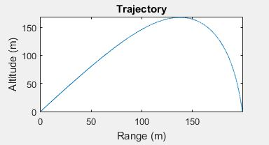

Fig 1 (*Altitude vs Range*)

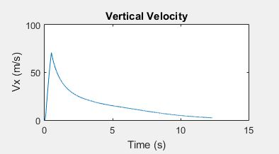

Fig 2 (*vertical velocity Graph*)

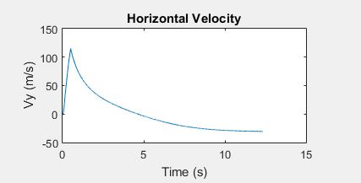

Fig 3 (*Horizontal Velocity Graph*)

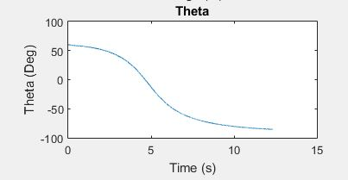

Fig 4 (*Theta vs Time* )

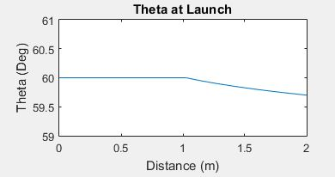

Fig 5 (*Theta vs Distance* )

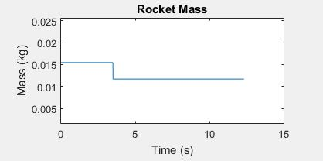

Fig 6 (*Mass vs Time*)

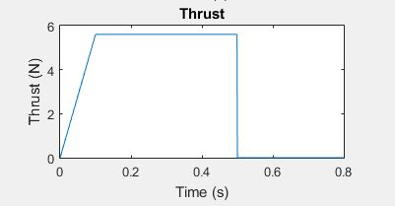

Fig 7 (*Thrust vs Time* )

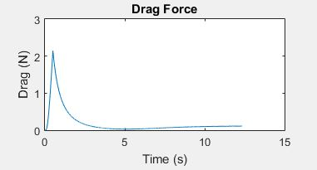

Fig 8 (*Drag Force vs Time* )

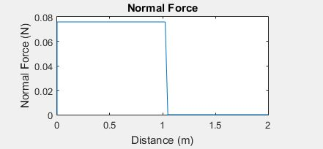

Fig 9 (*Normal Force vs Distance* )